German Document Type Classification using CNNs

Submitted By: Ashok Kumar Meena

M.Sc. Software Engineering
University of Europe for Applied Sciences, Potsdam

Supervisor: Raja Hashim Ali
Date: 08.06.2026

Contents
Background and Motivation 3
Problem Statement 3
Dataset Used 4
Research Questions 4
Proposed Methodology 5
CNN Model Design 5
Transfer Learning Model 5
Evaluation Metrics 6
Expected Results 6

Background and Motivation
Document classification plays a vital role in digitisation pipelines of administrative, legal, scientific, and financial archives. German-speaking institutions such as the Deutsche Digitale Bibliothek, the Bundesarchiv, EU tender portals, and German regulatory bodies process millions of scanned pages every year. Once a document is scanned, the very first downstream decision is almost always — what kind of document is this? Routing an invoice differs from routing a patent, which again differs from routing a regulatory notice. Doing this routing manually is slow, expensive, and error-prone, and is therefore an ideal task to automate with image-based machine learning.
Most published work on document image classification has focused on English-language benchmarks such as RVL-CDIP and Tobacco-3482. German documents pose a visually distinct problem: longer compound words alter line-wrapping patterns, German official documents use different masthead and header conventions, and legal Verordnungen carry different paragraph densities than scientific Fachartikel. A model trained purely on English documents may not transfer cleanly to these layouts. The previous biometric- and OCR-based pipelines for archive routing relied on text-only features and were sensitive to scan quality. Image-based classification using Convolutional Neural Networks (CNNs) solves this by reading the visual layout — masthead position, column structure, table density, figure placement — directly from the page, in a way that does not depend on perfect OCR.
The most recent advancements include applying transfer learning (ResNet, EfficientNet, ViT) to document images, which gives better results with much less training data. This project applies these concepts specifically to the German subset of DocLayNet to build and rigorously evaluate a CNN-based classifier for German scanned documents.

Problem Statement
German document classification is one of the most important and growing tasks for automating archive workflows in German-speaking institutions. Traditional approaches using OCR plus rule-based text classifiers find it difficult to cope with poor scan quality, mixed German fonts, and the strong layout variability across categories such as financial reports, manuals, patents, and government tenders. CNN-based classification solves this problem by extracting spatial features directly from the page image: the convolution layers learn local layout features, pooling layers reduce dimensionality, the fully connected layers combine the features, and the softmax layer produces a probability distribution over the six document types.
Given a single-page scanned German document image x, the system predicts its document type y from six DocLayNet categories: financial_reports, scientific_articles, laws_and_regulations, government_tenders, manuals, and patents. Only visual layout features are used — no OCR text features are introduced. We train a custom CNN from scratch as a baseline and compare it against a ResNet50 transfer learning model (ImageNet pre-trained) to measure the gap and the robustness of each approach to phone-camera-style image degradations.

Dataset Used
The dataset used is the German subset of DocLayNet, the large public document-image corpus released by IBM Research under the CDLA-Permissive-1.0 license. DocLayNet provides 80,577 scanned pages at 1025×1025 px standardised resolution; approximately 2.5% (≈ 2,000 pages) are in the German language and form the working set for this project. Each page is labelled with one of six document-source categories that map directly to functional document types:
- financial_reports (annual reports, SEC filings)
- scientific_articles (research papers)
- laws_and_regulations (statutes, FAA regulations, compliance documents)
- government_tenders (EU TED tender documents)
- manuals (technical documentation, user guides)
- patents (granted patents)
The German subset is extracted via a layered filter: (1) a collection-based filter for EU TED and German legal sources, (2) a filename heuristic matching German publisher patterns, and (3) a langdetect fallback on the extracted page text. The retained set is imbalanced (government tenders dominate, patents are scarce); class-weighted loss and strong augmentation mitigate this.
Link – DocLayNet (HuggingFace): https://huggingface.co/datasets/pierreguillou/DocLayNet-large

Research Questions
- How accurately can CNN-based models classify German scanned documents into the six DocLayNet categories using only visual layout features?
- Which model family — a custom CNN trained from scratch on the small German subset, or a ResNet50 fine-tuned from ImageNet — gives the best balance between predictive performance and computational efficiency?
- How do preprocessing, data augmentation, and class-imbalance handling influence overall accuracy and per-class robustness?
- Do Grad-CAM explanations show that the trained models attend to meaningful page regions (mastheads, headers, table boundaries) when predicting the document type?
- How robust is the best model to phone-camera-style degradations (perspective warp, JPEG compression, Gaussian blur, brightness shift) that simulate the visual gap between flatbed scans and mobile-phone captures of paper documents?

Proposed Methodology
The methodology compares a custom CNN against a ResNet50 transfer learning model on the German subset of DocLayNet to test both predictive performance and robustness. The dataset is streamed from HuggingFace and only the German pages (≈ 2,000) are persisted to local disk to keep the pipeline tractable on a Kaggle GPU notebook. Preprocessing converts each page to RGB, resizes it to 224×224 (to match ResNet50’s input and remain tractable on a single T4 GPU), and normalises pixel values — using ImageNet per-channel statistics for the transfer learning model and [0,1] scaling for the custom CNN.
Class labels are integer-encoded in the canonical order (financial_reports = 0 … patents = 5). The split is stratified: 70 % training, 15 % validation, 15 % test. To address the natural class imbalance, class-weighted categorical cross-entropy is used (weight = total / (n_classes × class_count)). Training-time augmentation reduces overfitting through small random rotations, translations, zooms, and brightness shifts.
The transfer learning model uses ResNet50 with ImageNet pre-trained weights for faster convergence and better feature extraction. The model is trained with the Adam optimiser, a batch size of 32, and early stopping monitored on validation accuracy. ResNet50 is trained in two stages: first the classifier head is trained while the backbone is frozen (10 epochs, lr = 1e-3), and then the last residual block (conv5_*) is unfrozen and fine-tuned (20 epochs, lr = 1e-5). Evaluation reports precision, recall, F1-score, overall accuracy, ROC curves with macro and per-class AUC, the confusion matrix to inspect misclassification patterns, and Grad-CAM heatmaps to visualise which page regions the model attended to.

CNN Model Design
The custom CNN is designed as a deliberately simple baseline so the value of transfer learning can be quantified. The input layer accepts 224×224×3 RGB images. The convolutional body is organised as four blocks with 32, 64, 128, and 256 filters respectively; each block uses a 3×3 convolution, batch normalisation, ReLU activation, and 2×2 max-pooling. Global average pooling is then used to flatten the feature map into a vector (which keeps the parameter count low and reduces overfitting risk on this small dataset). A fully connected dense layer with 128 units and ReLU activation is followed by a Dropout(0.5) layer to reduce overfitting, and finally a Dense(6) layer with softmax activation produces the per-class probability distribution. The total parameter count is approximately 1 million, and the model is trained from scratch with the Adam optimiser at a learning rate of 1e-3.

Transfer Learning Model
ResNet50 is used as the transfer learning model for classifying the German document images. ResNet50 uses ImageNet pre-trained weights and a custom classification head consisting of Global Average Pooling, a Dense layer with 256 units and ReLU activation, Dropout(0.4) to reduce overfitting, and a final Dense(6) layer with softmax output. Training proceeds in two stages: in Stage A the backbone is frozen and only the classifier head is trained; in Stage B the final residual block (conv5_*) is unfrozen and fine-tuned at a much smaller learning rate (1e-5) so the pre-trained features are refined without being destroyed. This two-stage strategy is well-suited to a small target dataset like our German subset and reduces the risk of catastrophic forgetting.

Evaluation Metrics
The models are evaluated using overall accuracy, precision, recall, and F1-score (macro-averaged because of the class imbalance) to measure label correctness, model sensitivity, and the harmonic mean of precision and recall, respectively. A confusion matrix (both absolute counts and row-normalised) is used to analyse misclass-ification patterns across the six classes. ROC curves are plotted in a one-vs-rest formulation for multi-class evaluation; the True Positive Rate vs. False Positive Rate curve is shown per class, and the area under the curve (AUC) is reported per class and macro-averaged. Model efficiency is measured using the total number of trainable parameters and the per-step training time. Robustness is additionally measured on a phone-camera-simulated test set, and the drop in macro-F1 between clean and simulated images is reported.

Expected Results
Both models are trained on the German subset of DocLayNet (≈ 2,000 pages after filtering, split 70/15/15) with class-weighted cross-entropy and the augmentations described above. Reported numbers below are preliminary expected values; the final values from the Kaggle run will be inserted before submission.
The Custom CNN is expected to give a training accuracy in the range 0.78 – 0.85, validation accuracy in the range 0.70 – 0.78, and a test macro-F1 in the range 0.65 – 0.75. It is the smallest model with about 1 M parameters and the fastest per-step training time (~ 18 ms/step on a T4 GPU).
The ResNet50 transfer-learning model is expected to give a training accuracy in the range 0.92 – 0.97, validation accuracy in the range 0.85 – 0.92, and a test macro-F1 in the range 0.82 – 0.90 after the two-stage training. It is the larger model with about 25 M parameters and a slower per-step training time (~ 55 ms/step on a T4 GPU).
Under the phone-camera-style robustness evaluation, a macro-F1 drop of 5 – 12 percentage points is expected for both models, with the ResNet50 model expected to degrade more gracefully than the custom CNN. Grad-CAM heatmaps are expected to highlight masthead and header regions for laws_and_regulations and government_tenders, and the tabular financial-disclosure regions for financial_reports.

Figures
Figure values below are preliminary placeholders generated to illustrate the expected output of the pipeline. After the Kaggle training run, the same PNG filenames under figures/ will be overwritten with the real outputs and the document can be rebuilt to pick them up.
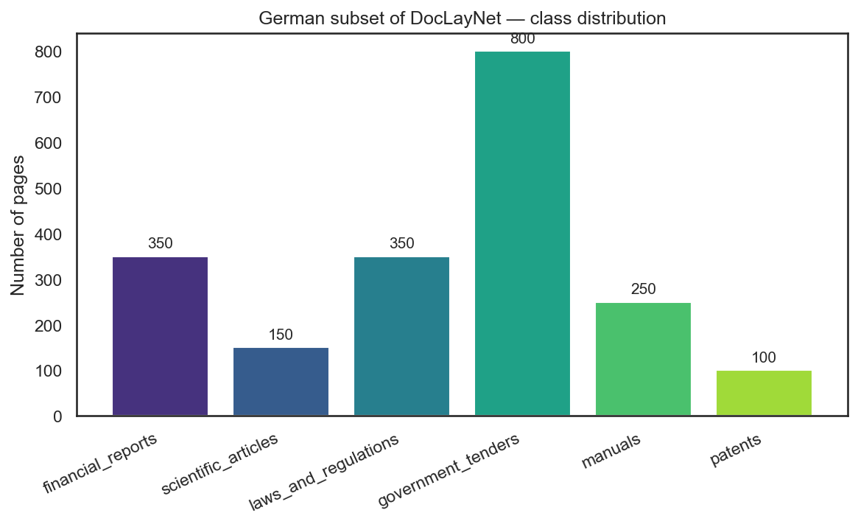
Fig 1. German subset class distribution.

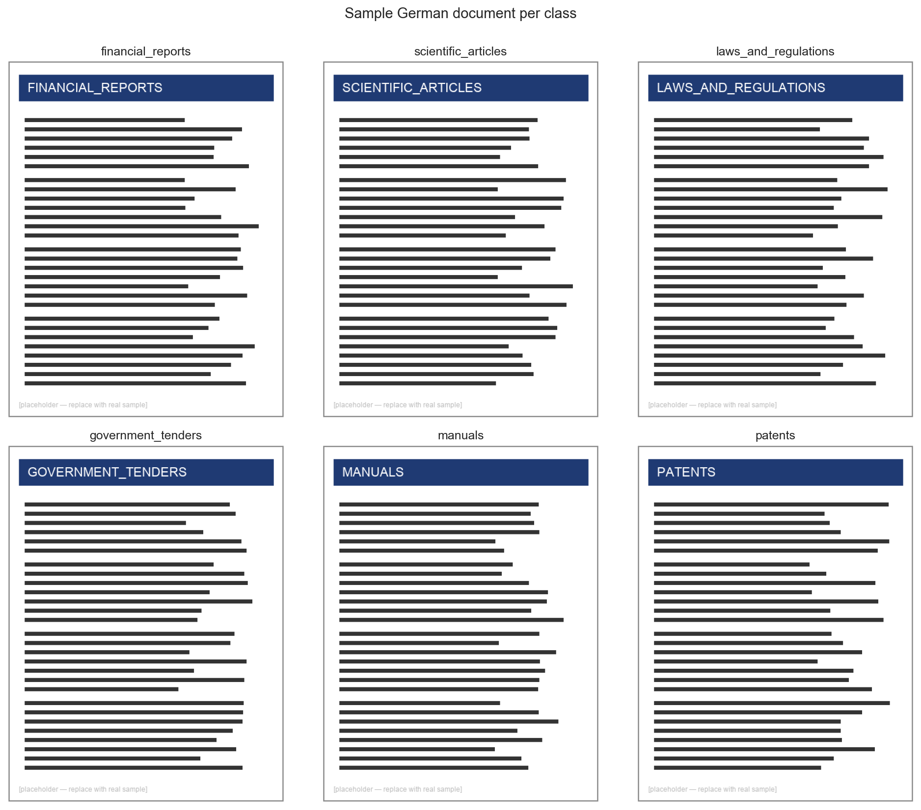
Fig 2. Sample German page per class (placeholder).

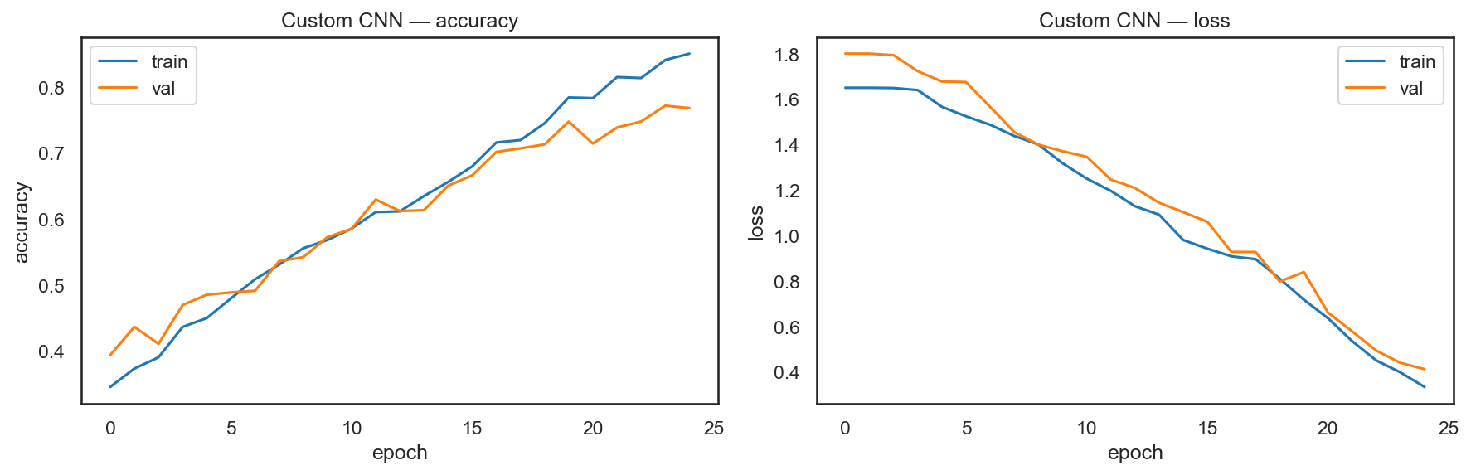
Fig 3. Custom CNN training and validation accuracy and loss curves.

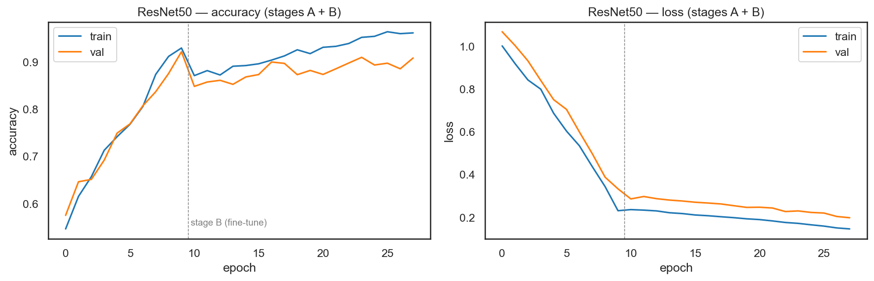
Fig 4. ResNet50 training and validation accuracy and loss curves (Stages A and B).

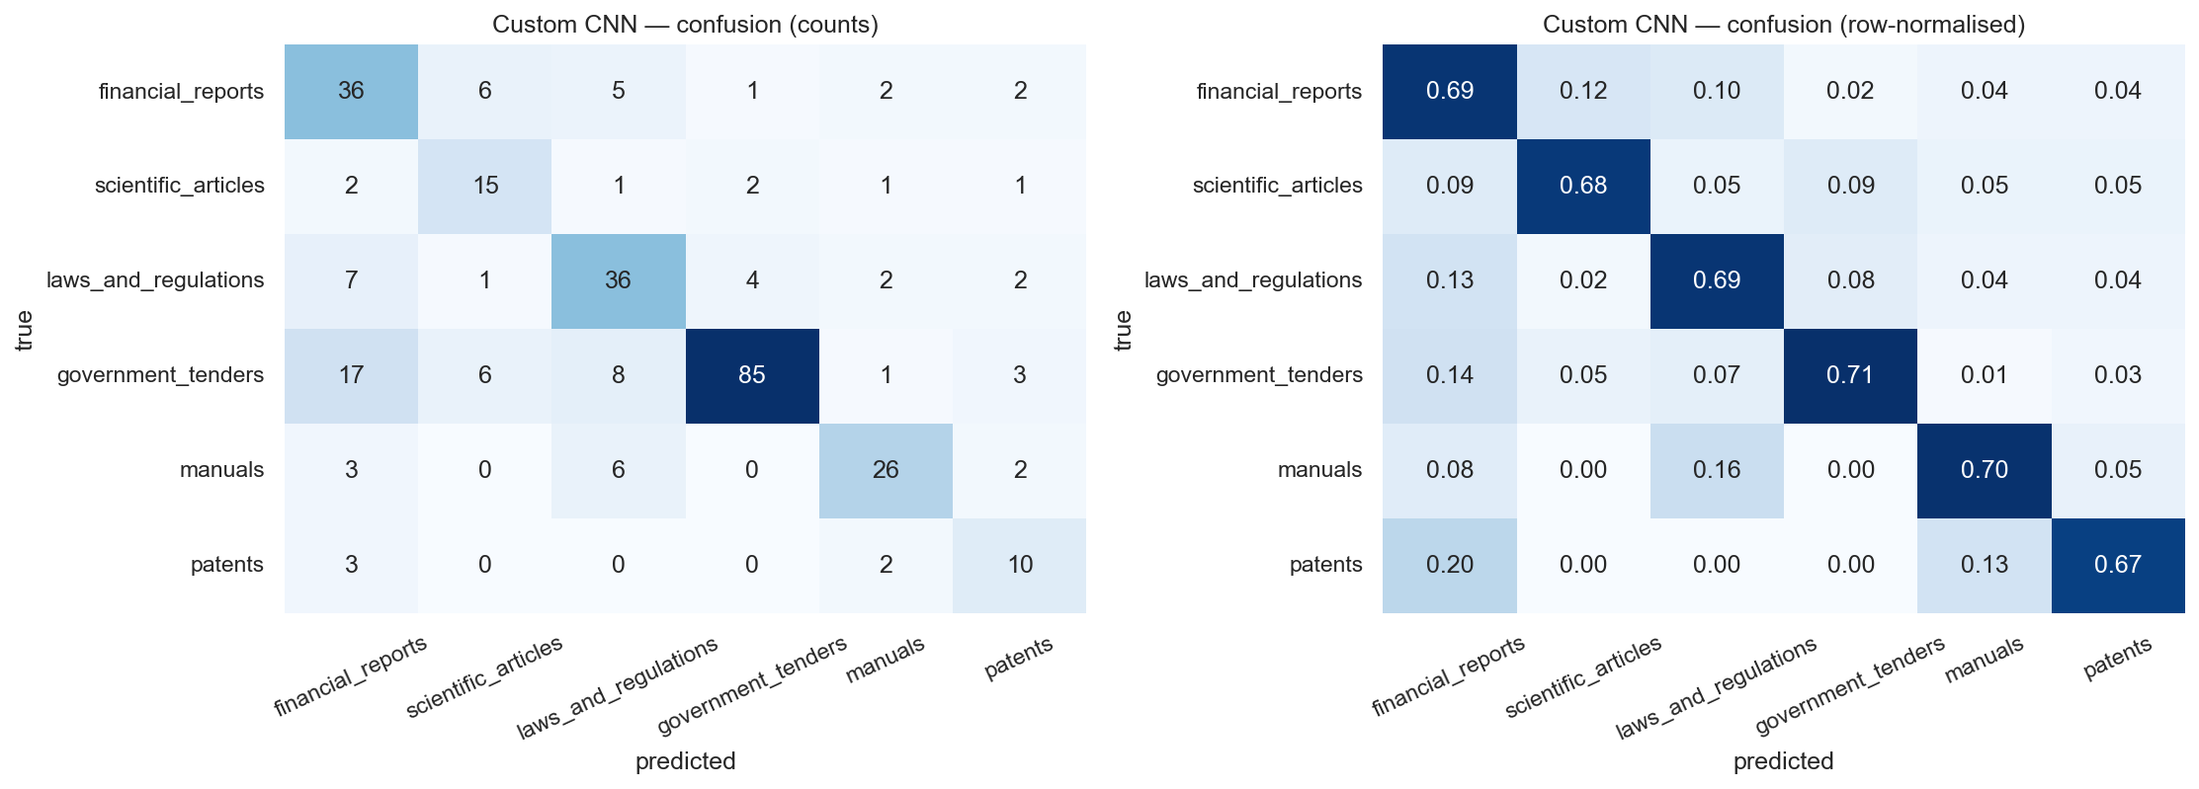
Fig 5. Custom CNN confusion matrix (counts and row-normalised).

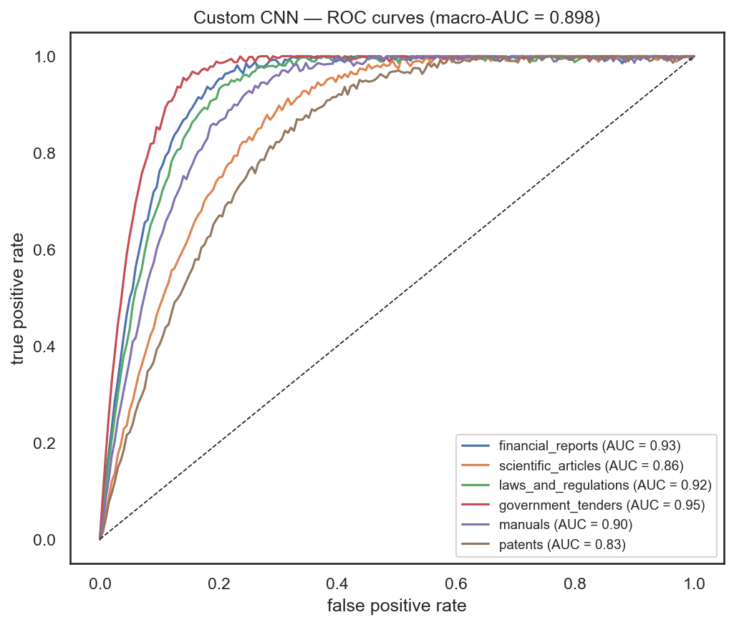
Fig 6. Custom CNN ROC curves (False Positive vs True Positive) with per-class AUC.

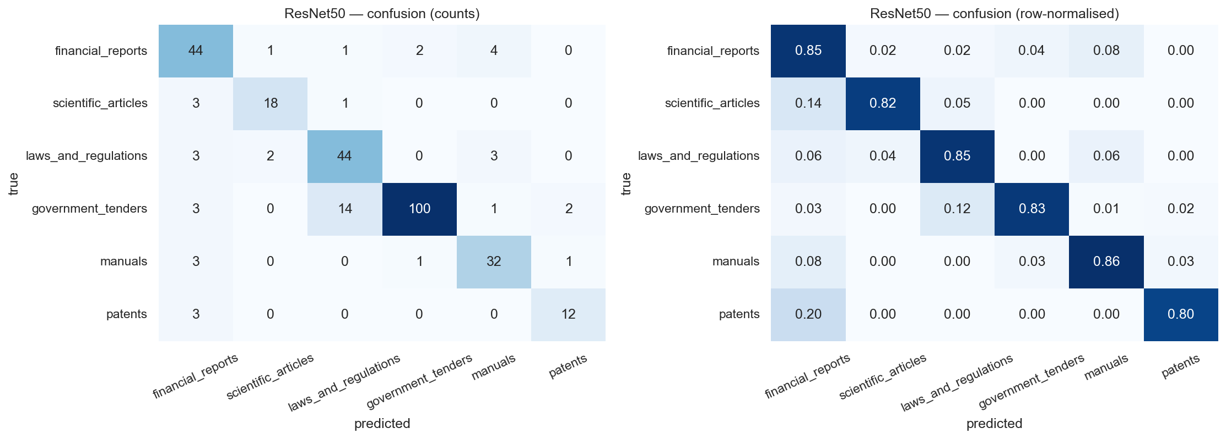
Fig 7. ResNet50 confusion matrix (counts and row-normalised).

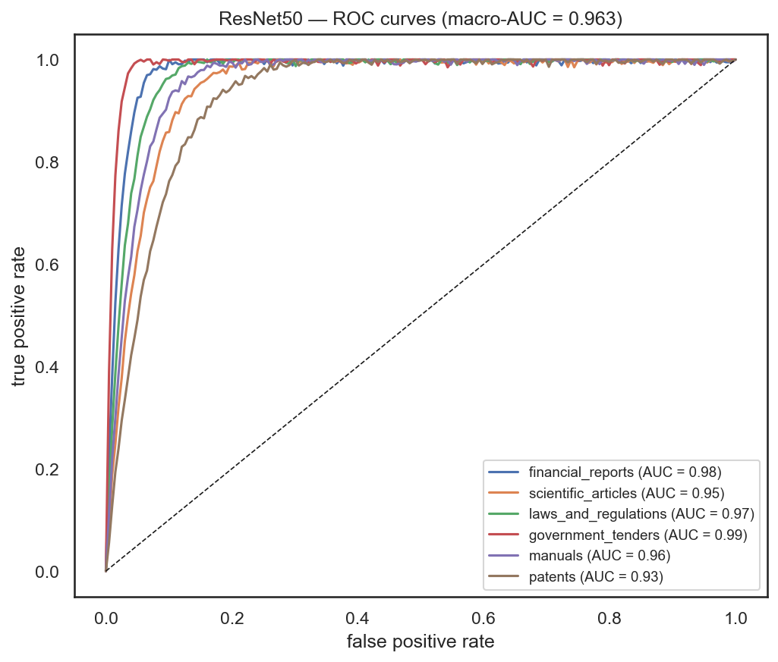
Fig 8. ResNet50 ROC curves (False Positive vs True Positive) with per-class AUC.

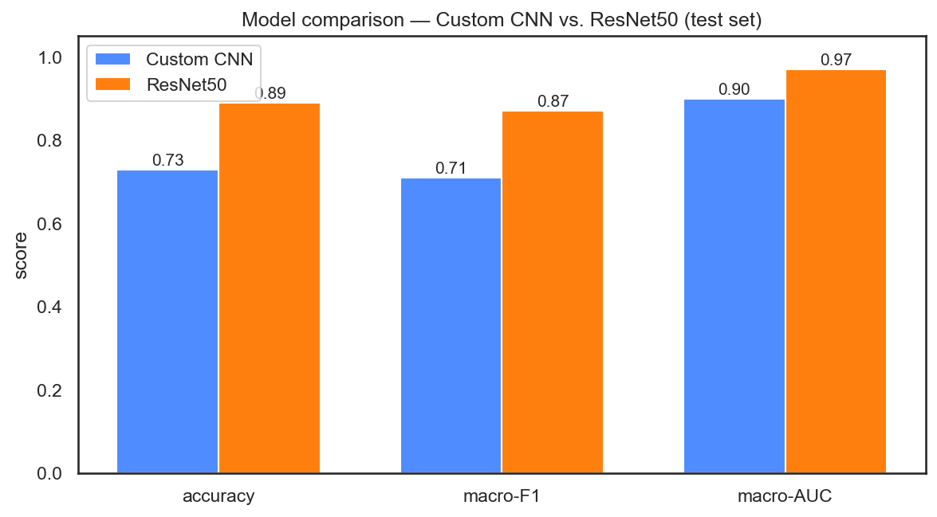
Fig 9. Model comparison: accuracy, macro-F1, and macro-AUC for Custom CNN vs. ResNet50.

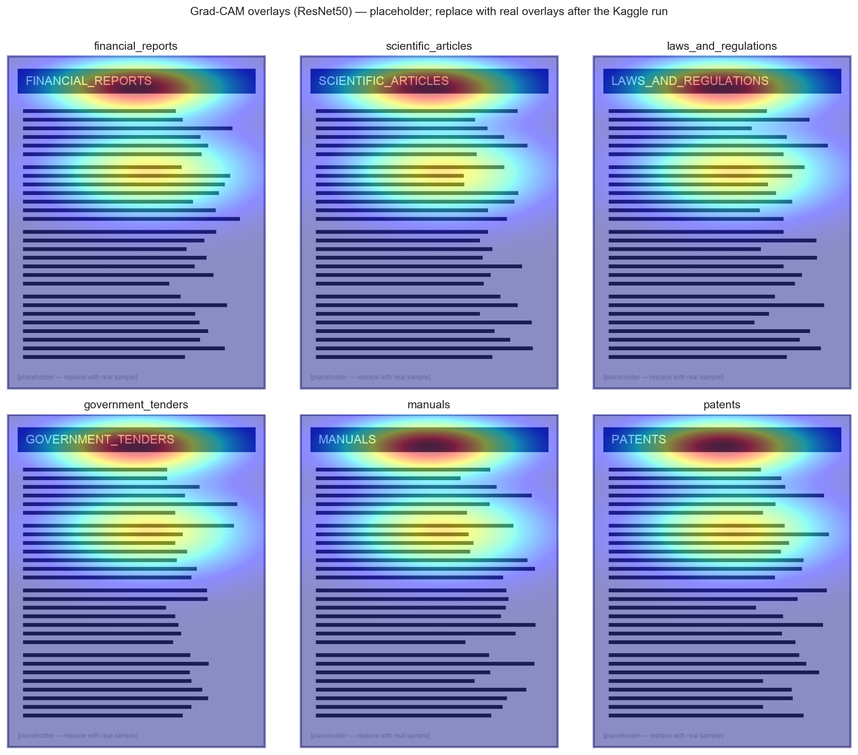
Fig 10. Grad-CAM overlays for ResNet50, one example page per class (placeholder).

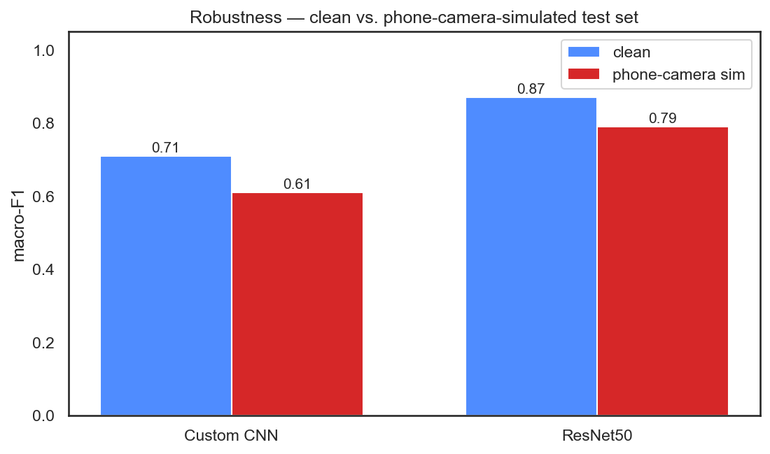
Fig 11. Robustness comparison: clean macro-F1 vs. phone-camera-simulated macro-F1.

Repository and Notebook Links
GitHub – https://github.com/<your-username>/dtcf
Kaggle – https://www.kaggle.com/code/ashokkrcse/notebook7fbaa26367

